Power BI Desktop

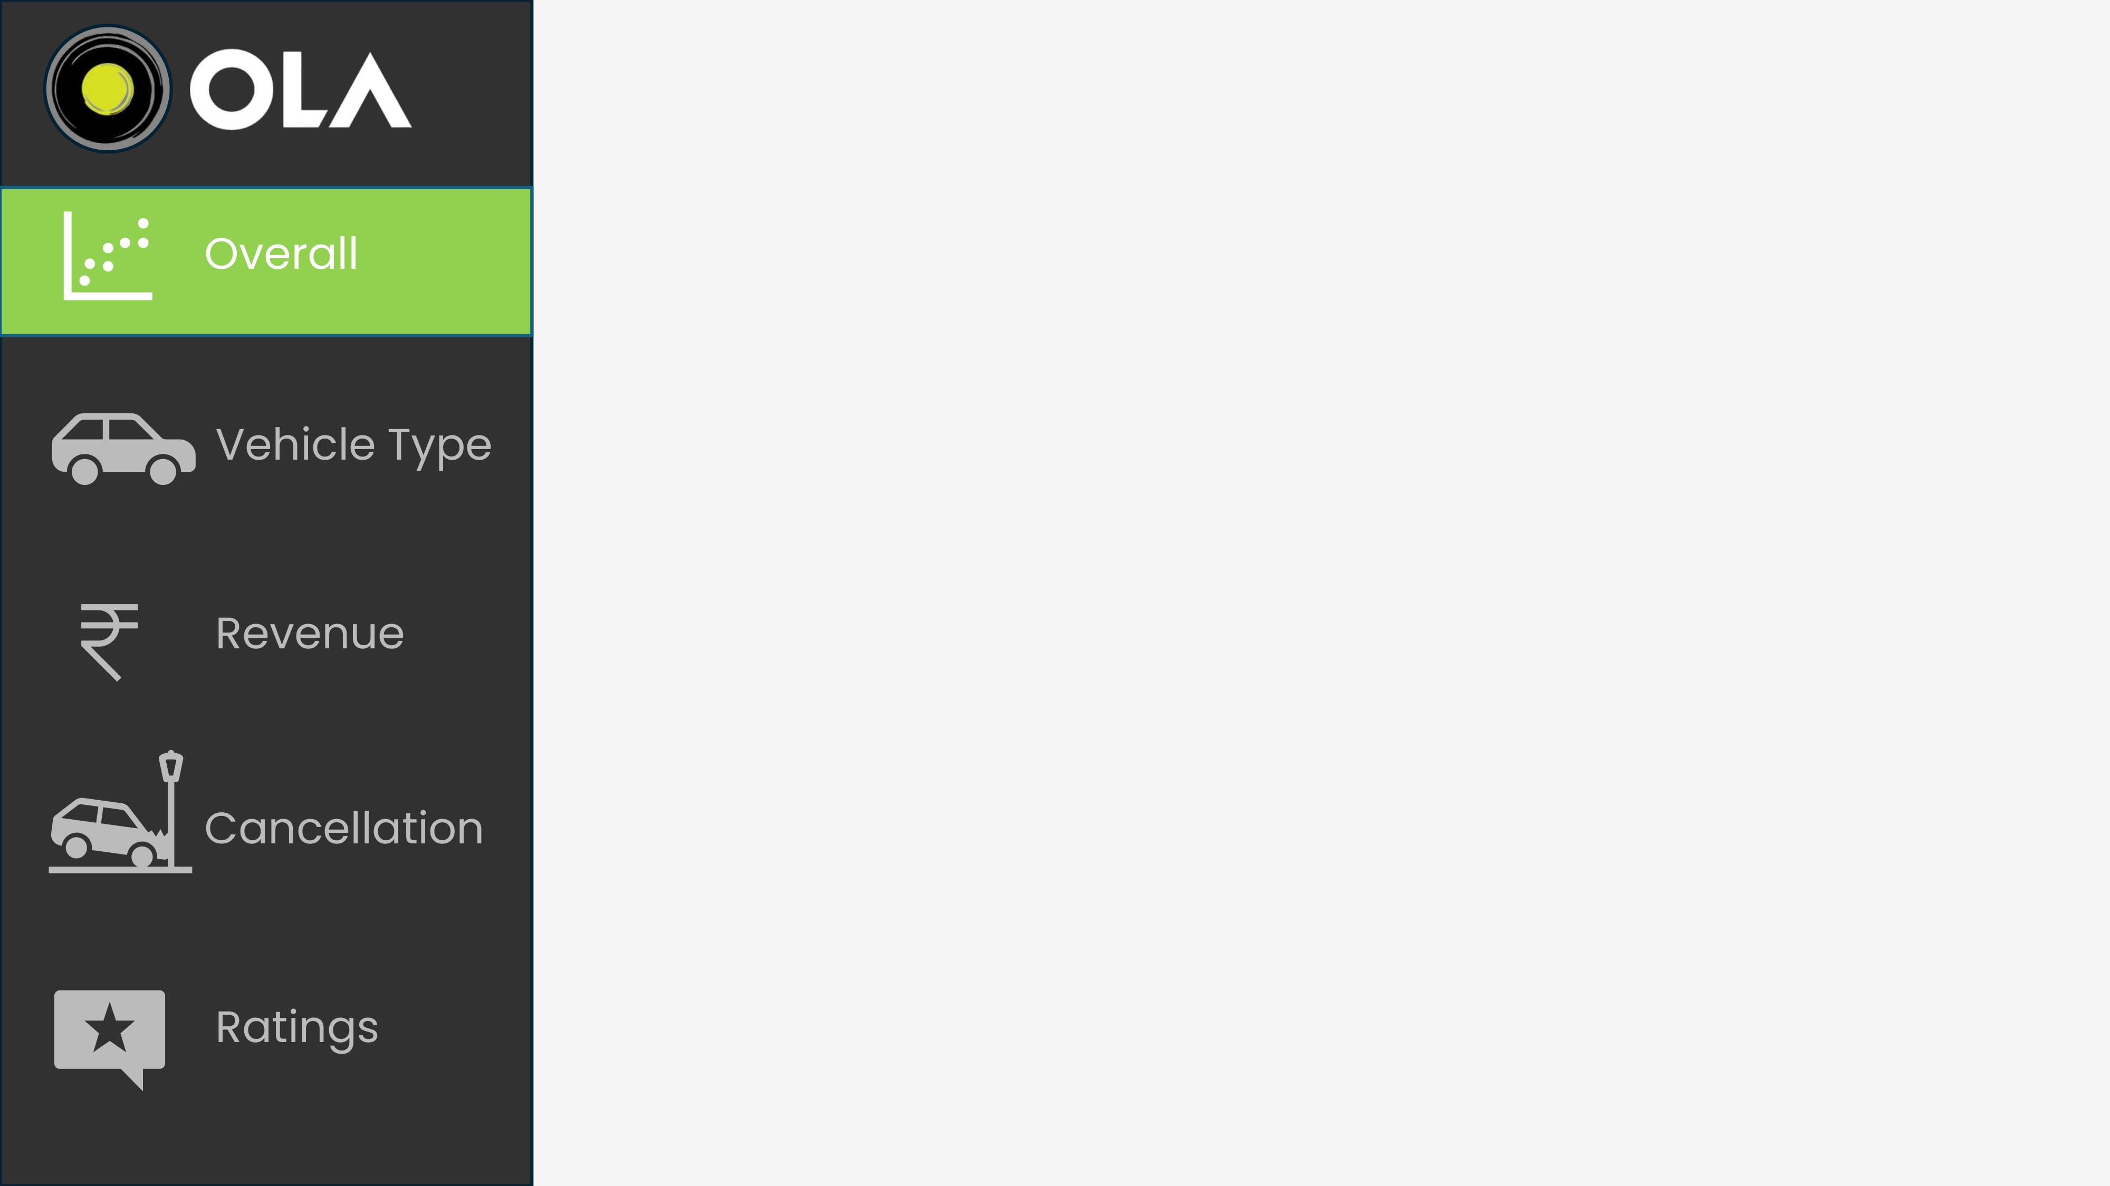

**Ride Volume Over Time**

**6,000**

**6,500**

**7,000**

**Date**

**Count o**

**f Booking**

**Jul**

**07**

**Jul**

**14**

**Jul**

**21**

**Jul**

**28**

6702

6144

6864

6492

6484

6750

6818

6446

6474

6614

6776

6718

6548

**Booking Status Breakdown**

**127.93K (62.09%)**

**(17.89%)**

**K (10.19%**

**)**

**21**

**K (9.83%**

**20.25**

**)**

**36.87**

**K**

**Success**

**Canceled by Driver**

**Canceled by Customer**

**Driver Not Found**

**DATE**

**01-07-2024**



**31-07-2024**



**TOTAL BOOKING**

K

206.05

**TOTAL VALUES**

M

70

Power BI Desktop

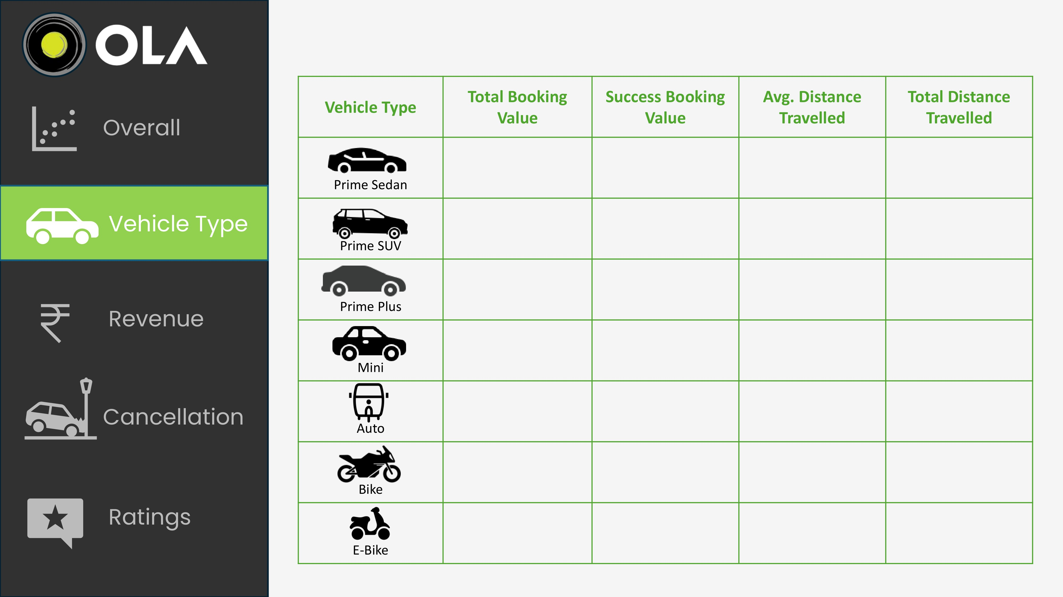

17

M

16

M

M

16

16

M

M

16

16

M

16

M

10

M

M

10

M

10

10

M

M

10

10

M

10

M

25.01

24.88

25.03

24.98

10.04

24.93

25.15

K

469

448

K

454

K

K

451

K

184

455

K

K

462

**01-07-2024**



**31-07-2024**



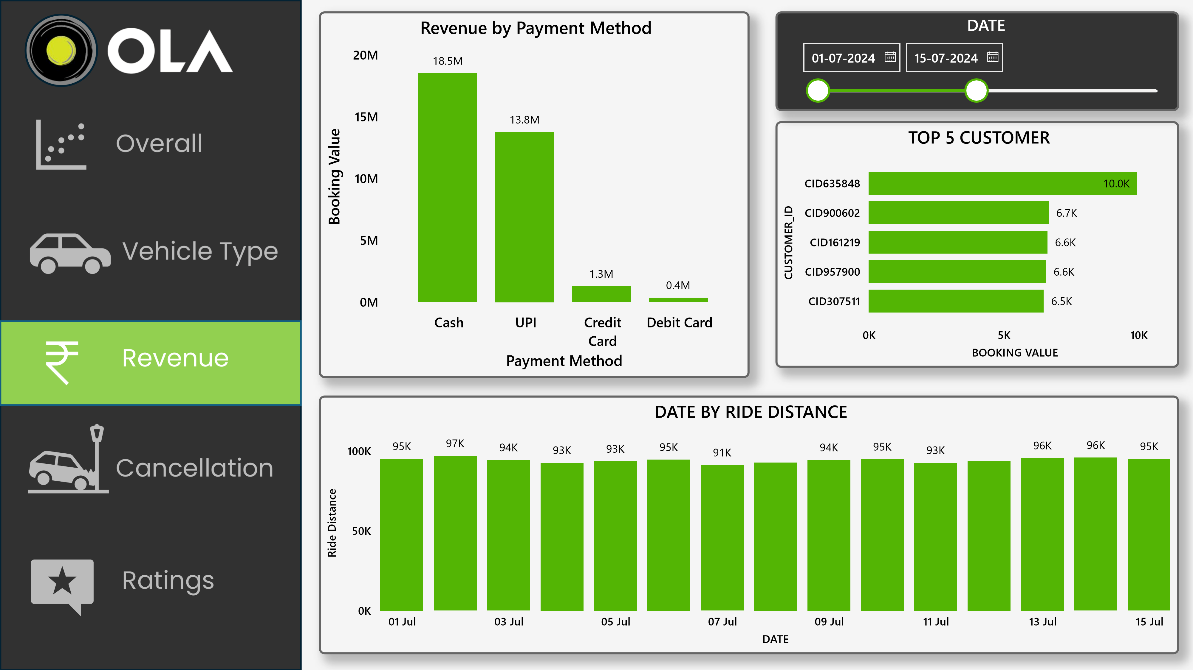

Power BI Desktop

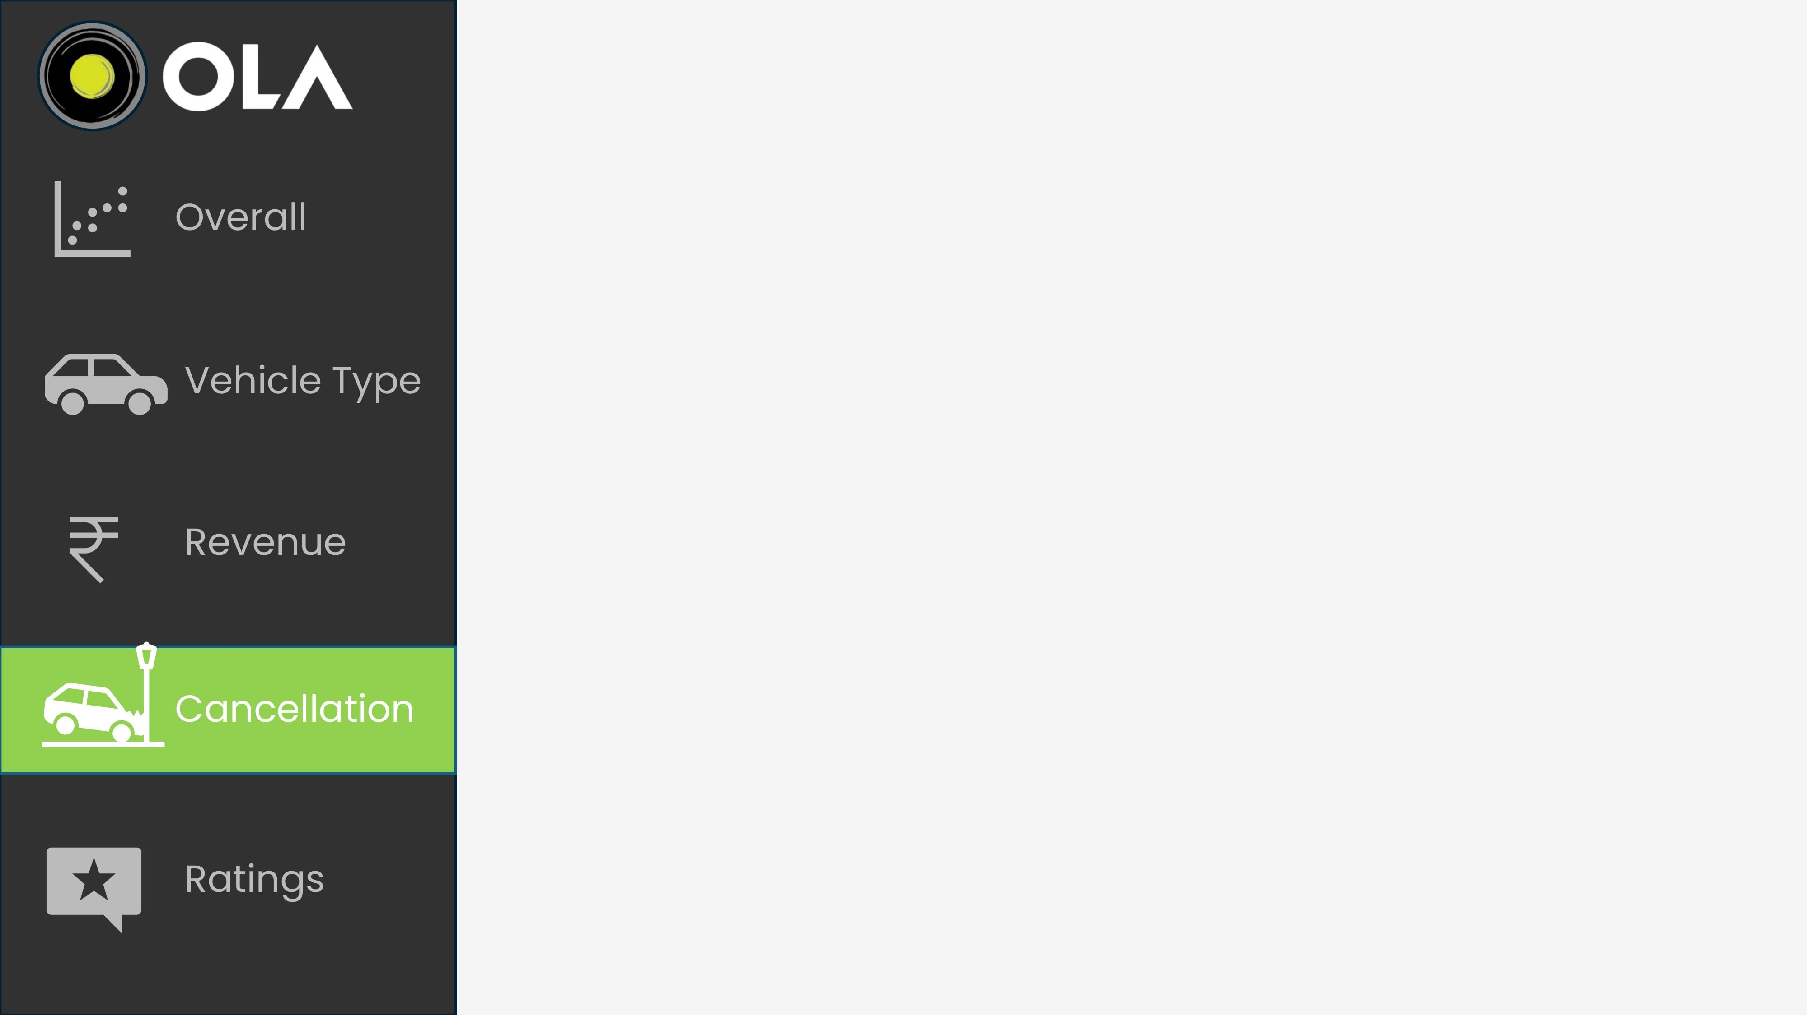

**CANCELED BY CUSTOMER**

**6.35**

**)**

**K (30.24%**

**5.34**

**K (25.43%**

**)**

**4.16**

**K (19.82%**

**)**

**(14.93%)**

**)**

**K (9.57%**

**2.01**

**K**

**3.14**

**Driver is not moving tow…**

**Driver asked to cancel**

**Change of plans**

**AC is Not working**

**Wrong Address**

**CANCELED BY DRIVER**

**13.08**

**K (35.49%**

**)**

**10.83**

**K (29.36%**

**)**

**(19.82%)**

**5.65**

**K (15.32%**

**)**

**7.31**

**K**

**Personal & Car related is…**

**Customer related issue**

**Customer was coughing…**

**More than permitted pe…**

**DATE**

**01-07-2024**



**31-07-2024**



**TOTAL BOOKING**

K

206.05

**SUCCESS BOOKING**

127.93

K

**CANCELED BOOKING**

57.87

K

**Canceled Rate**

28.08

%

Power BI Desktop

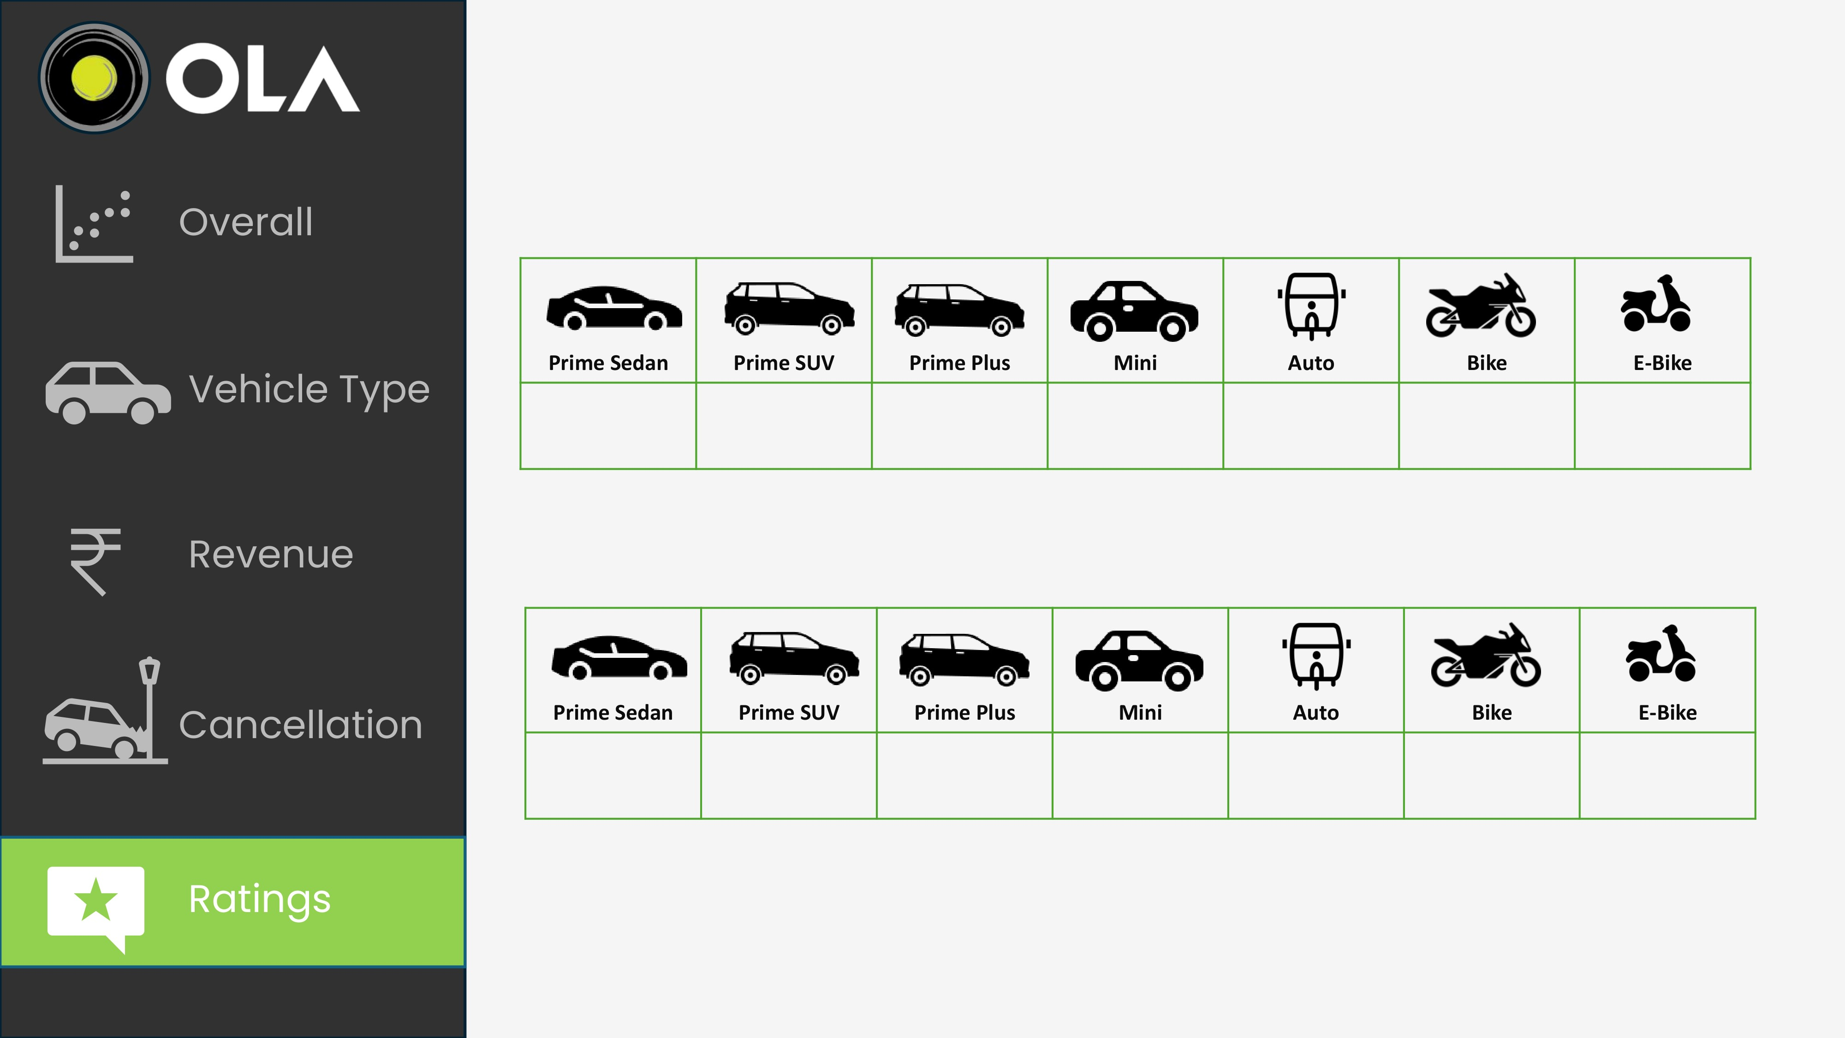

4.00

4.01

4.00

3.99

4.00

3.98

4.01

**DRIVER RATING**

3.99

4.00

4.01

4.00

4.00

3.99

3.99

**CUSTOMER RATING**